**Github link;** [**https://github.com/blacklightske/website-group-work.git**](https://github.com/blacklightske/website-group-work.git)

**WEBSITE DESIGN**

**ORACLE COLLECTION**

**HOME**

**MUSIC**

**NOVELS**

**BLOG**

**About us**

**MOVIES**

**BLOG**

**NOVELS**

**MUSIC**

**EMAIL ADRESS**

**PHONE NUMBER**

**INSTAGRAM**

**FACEBOOK**

**SCREENSHOTS**

**Home page**

**Novels page**

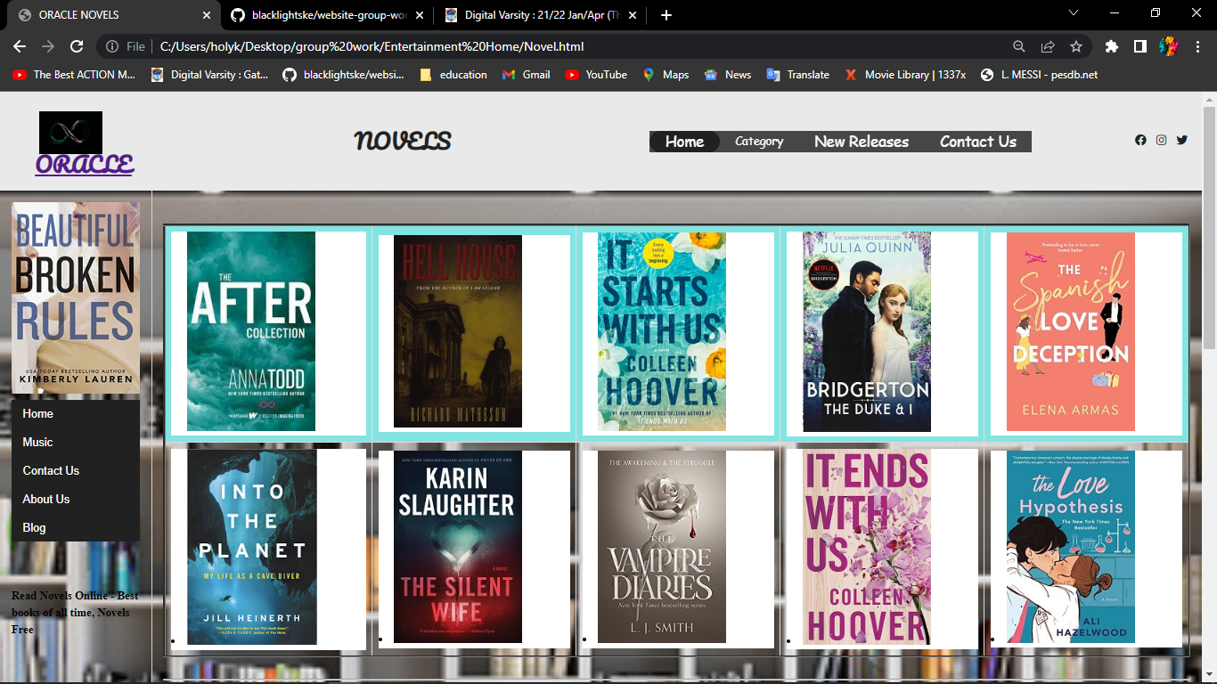

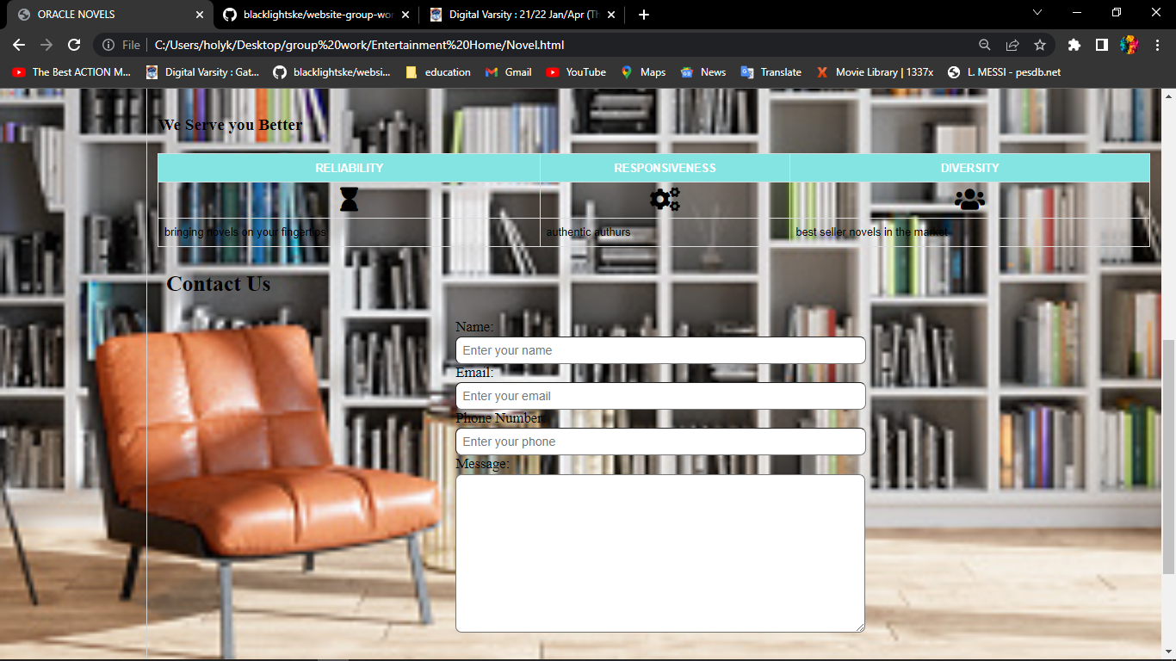

**Movies page**

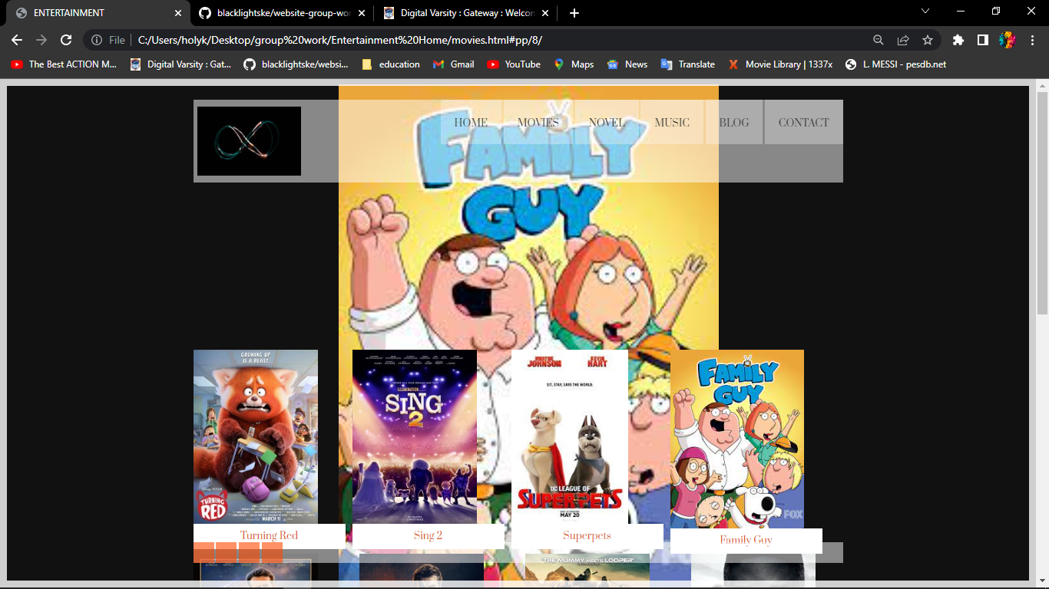

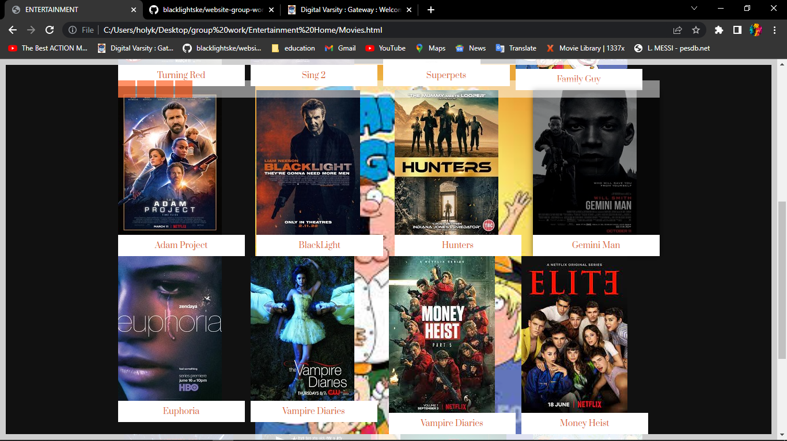

**MUSIC PAGE**

**BLOG PAGE**

**CONTACT US PAGE**

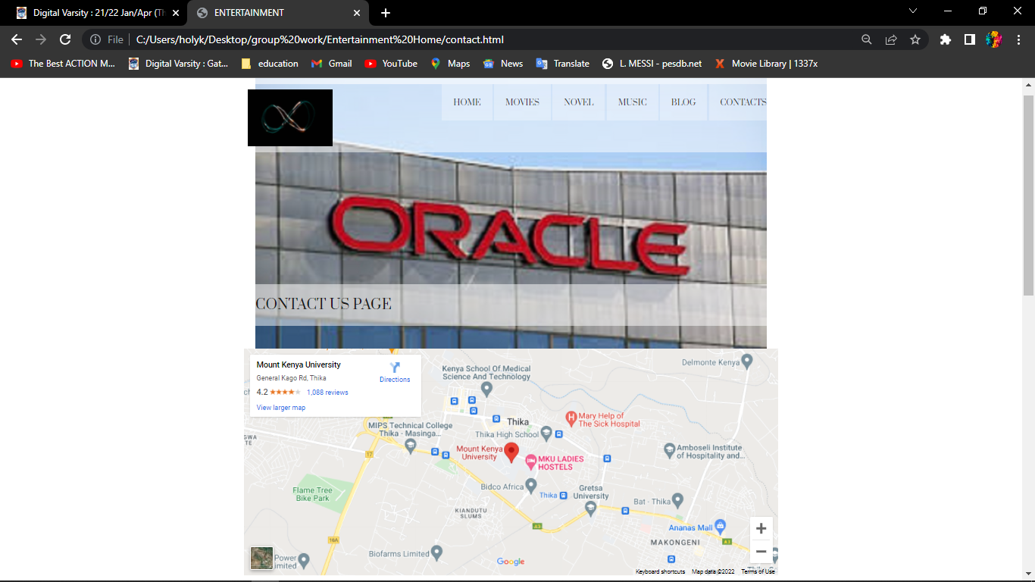

**GITHUB LINK; https://github.com/blacklightske/website-group-work.git**